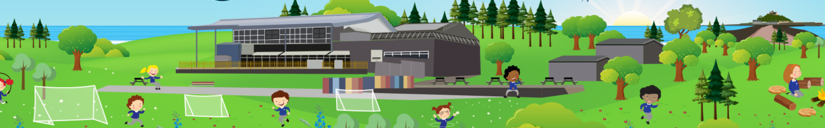
Godrevy Class Timetable

DAY | 8:50  -  9:15 | 9:15  -  10:00 | 10:00 – 10:15 | 10:15  -  10.30 | 10.30  -  10.40 | 10:40 – 11:20 | 11:25 – 12:00 | 12:00  -  12:45 | 13:00  –  13:20 | 13:20  -  14:05 | 14:05  -  14:50 | 14:50 – 15:05
Monday | Maths Mastery | Reading | Spelling/RWI writing | Break time | Arithmetic | Maths | English  Handwriting  Red word reading  1;1 phonics | LUNCH | Assembly  Picture news | Foundational | Foundational | Reading for pleasure
Tuesday | Maths Mastery | Reading | Spelling/RWI writing | Break time | Arithmetic | Maths | English | LUNCH | Assembly  Author of the term | PPA |  | Reading for pleasure
Wednesday | Maths Mastery | Reading | Spelling/RWI writing | Break time | Arithmetic | Maths | English | LUNCH | Assembly  Visitor or class | Foundational | Foundational | Reading for pleasure
Thursday | Maths Mastery | Reading | Spelling/RWI writing | Break time | Arithmetic | Maths | English | LUNCH | Assembly  Artist/  musician of the term | Foundational | PE | Reading for pleasure
Friday | Maths Mastery | Reading | Spelling/RWI writing | Break time | Arithmetic | Maths | English | LUNCH | Assembly – Star certificates | Foundational | PE | Golden time

