

Pensans Community Primary School

PSHE, RELATIONSHIPS & SEX EDUCATION POLICY

Written: July 2026

Review date: July 2028

Pensans CP School
PSHE, Relationship and Sex Education Policy

INTRODUCTION AND CONTEXT

The aim of this policy is to clarify the content, principles and delivery of Relationships, Sex and Health Education (RSHE) at Pensans Community Primary School. This policy has been developed in accordance with the Department for Education's Relationships Education, Relationships and Sex Education (RSE) and Health Education Statutory Guidance (appendix 1) (effective from September 2026) and reflects the requirements of the Relationships Education, Relationships and Sex Education and Health Education (England) Regulations 2019, made under sections 34 and 35 of the Children and Social Work Act 2017.

Relationships Education is compulsory for all pupils in primary education, and Health Education is compulsory in all state-funded schools. At Pensans Primary School, we recognise that high-quality RSHE is an essential part of safeguarding and promoting children's personal development, wellbeing and preparation for life in modern Britain.

This policy should be read alongside the school's Safeguarding and Child Protection Policy, Behaviour Policy, Anti-Bullying Policy, Online Safety Policy, Equality Policy, SEND Policy and PSHE Policy.

Today's children are growing up in an increasingly complex, diverse and interconnected world where much of their communication, learning and social interaction takes place both online and offline. Whilst technology provides many positive opportunities, it also presents new and evolving risks. Children need the knowledge, understanding and skills to build healthy relationships, make informed and safe choices, recognise unhealthy or unsafe situations and know how and where to seek help.

The Department for Education's updated statutory guidance places greater emphasis on:

* developing healthy, respectful and inclusive relationships;
* understanding personal boundaries and consent in an age-appropriate way;
* recognising unsafe, coercive or abusive behaviours;
* online safety, including social media, gaming, livestreaming and emerging technologies such as artificial intelligence (AI), manipulated or AI-generated images, misinformation and deepfakes;
* recognising trusted adults and knowing how to report concerns;
* promoting emotional wellbeing, resilience and positive mental health;
* respecting diversity and the protected characteristics defined within the Equality Act 2010.

At Pensans Primary School, we believe that Relationships and Sex Education is fundamental to enabling children to become safe, confident, respectful and responsible members of society. Our curriculum supports pupils in developing the knowledge, vocabulary and confidence to understand themselves, build positive relationships and make informed decisions as they grow.

We teach RSHE within the context of the school's vision, values and ethos. Our curriculum promotes kindness, respect, responsibility, inclusion and empathy, encouraging pupils to value themselves and others whilst celebrating diversity within our local, national and global communities.

Whilst aspects of sex education are taught within the statutory Science National Curriculum, our wider RSHE programme provides age-appropriate learning that enables pupils to understand human development, puberty, families and healthy relationships. All teaching is delivered sensitively, inclusively and in a developmentally appropriate manner, recognising the diverse backgrounds, beliefs and experiences of our pupils and families.

Parents and carers are recognised as children's first educators. Pensans Community Primary School is committed to working in partnership with families by providing opportunities to view curriculum resources, understand what is taught in each year group and discuss any questions or concerns. We believe that open communication between home and school helps ensure children receive consistent, accurate and supportive messages about relationships, health and wellbeing.

Our RSHE curriculum forms an integral part of our wider Personal, Social, Health and Economic (PSHE) education programme and contributes significantly to our safeguarding responsibilities. Through high-quality teaching and a whole-school approach, we aim to equip every child with the knowledge, skills and confidence they need to lead healthy, happy and safe lives, both now and in the future.

Key statutory documents

* Department for Education: Relationships Education, Relationships and Sex Education (RSE) and Health Education Statutory Guidance(effective September 2026)
* Children and Social Work Act 2017
* Relationships Education, Relationships and Sex Education and Health Education (England) Regulations 2019
* Keeping Children Safe in Education (latest edition) (appendix 2)
* Equality Act 2010
* Prevent Duty Guidance
* UK General Data Protection Regulation (UK GDPR) where relevant to safeguarding and online safety.

AIMS
Relationships, Sex and Health Education (RSHE) at Pensans Community Primary School aims to provide children with the knowledge, understanding, skills and values they need to lead safe, healthy and fulfilling lives. Through a carefully planned, age-appropriate curriculum, pupils are supported to develop respectful relationships, understand their own health and wellbeing, and become responsible members of society.
Our RSHE curriculum aims to:
- Develop children's understanding of themselves and their changing bodies, enabling them to recognise, respect and care for their bodies and understand the physical and emotional changes associated with growing up and puberty in an age-appropriate, factual and sensitive manner.
- Promote healthy, positive and respectful relationships by helping children to develop kindness, empathy, trust, honesty and respect for others. Pupils will learn about different families, friendships and communities, recognise the characteristics of healthy relationships and understand the importance of treating everyone with dignity and respect.
- Promote emotional health, wellbeing and resilience, enabling children to develop self-esteem, confidence and a positive sense of identity. Pupils will learn strategies to manage emotions, build resilience, challenge stereotypes and appreciate diversity within modern British society.
- Develop children's understanding of personal safety and safeguarding, ensuring they know how to recognise unsafe situations, inappropriate behaviour, coercion or abuse, understand age-appropriate concepts of personal boundaries and consent, and know when, how and from whom to seek help.
- Prepare children for life in an increasingly digital world by developing the knowledge and skills to form safe and respectful online relationships. Pupils will learn about online safety, privacy, digital footprints, respectful communication, cyberbullying, misinformation, artificial intelligence (AI), manipulated images and deepfakes in ways that are appropriate to their age and stage of development.
- Promote equality, inclusion and respect for diversity, ensuring pupils understand that every individual should be treated fairly and with respect, recognising the protected characteristics within the Equality Act 2010 and celebrating the diversity of families and communities.
- Equip children with the knowledge and confidence to make informed, responsible decisions about their health, wellbeing and relationships, enabling them to become active, respectful and responsible citizens who are prepared for the opportunities, responsibilities and experiences of later life.
Our RSHE curriculum is delivered through a whole-school approach that supports pupils' personal development, complements the National Curriculum for Science and Health Education, and reflects the school's safeguarding responsibilities and values.

CURRICULUM CONTENT

At Pensans Community Primary School, we promote children's personal development, wellbeing and safeguarding through a comprehensive Personal, Social, Health and Economic (PSHE) education programme. Our curriculum equips pupils with the knowledge, understanding, attitudes and practical skills they need to lead safe, healthy and fulfilling lives, develop positive relationships and become active, responsible members of society.

Our RSHE curriculum fulfils the statutory requirements for Relationships Education and Health Education, as outlined in the Department for Education's Relationships Education, Relationships and Sex Education (RSE) and Health Education Statutory Guidance (2026). The curriculum is carefully planned to be age-appropriate, inclusive, evidence-informed and responsive to the needs of our pupils and the local community.

Teaching is progressive, building on children's prior learning from the Early Years Foundation Stage through to Year 6. Learning is revisited and developed over time, enabling pupils to deepen their understanding and apply their knowledge confidently in a range of real-life situations.

Whilst the statutory National Curriculum for Science teaches pupils about human growth, reproduction and the changing body, our wider RSHE curriculum enables children to explore relationships, health, emotional wellbeing, personal safety and safeguarding in a supportive and age-appropriate environment. Together, these subjects provide pupils with a comprehensive understanding of physical, emotional and social development.

Class teachers are responsible for delivering RSHE within their own classes and are supported through high-quality curriculum planning, professional development and safeguarding guidance. Lessons are delivered sensitively and inclusively, recognising the diverse experiences, backgrounds and beliefs of our pupils and families. Teachers use professional judgement to ensure that learning remains developmentally appropriate whilst meeting statutory expectations.

To deliver our RSHE curriculum, Pensans Community Primary School uses both the Christopher Winter Project and the LifeWise PSHE and Activity Scheme across all year groups from Reception to Year 6. These programmes provide a structured, progressive and age-appropriate curriculum that meets statutory requirements whilst reflecting the values and ethos of our school. The content is supplemented where appropriate to ensure it reflects current statutory guidance, emerging safeguarding priorities and the needs of our pupils.

Ground rules are established at the beginning of all RSHE lessons to create a safe, respectful and inclusive learning environment where pupils feel confident to participate, ask questions and express their views appropriately. These expectations are consistent with those used throughout our wider PSHE curriculum and promote respectful discussion, active listening and confidentiality within agreed safeguarding boundaries.

Teachers encourage pupils to ask questions and foster an open, supportive classroom culture. An anonymous question box may be used where appropriate to enable children to raise sensitive questions without embarrassment. Staff will answer questions honestly, factually and in an age-appropriate manner, using professional judgement to determine whether a question is suitable for whole-class discussion or whether individual support is more appropriate. Where necessary, teachers may advise that a question will be discussed at a later stage of the curriculum or, where safeguarding concerns arise, follow the school's safeguarding procedures.

In line with current statutory guidance, our curriculum also prepares pupils to understand and navigate the opportunities and challenges of modern life. This includes teaching children how to:

- develop healthy, respectful and positive relationships;
- recognise trusted adults and know how to seek help;
- understand personal boundaries and age-appropriate concepts of consent;
- stay safe online, including when using social media, gaming platforms and emerging technologies;
- recognise cyberbullying, online exploitation, misinformation, manipulated or AI-generated images and inappropriate online content;
- value diversity, challenge stereotypes and respect the rights and beliefs of others;
- understand the importance of mental wellbeing, resilience and healthy lifestyles.

Our RSHE curriculum forms a key part of the school's wider safeguarding provision and contributes significantly to pupils' personal development. It enables children to develop the knowledge, vocabulary and confidence to recognise concerns, report worries and make informed choices that support their safety, wellbeing and future success

The objectives of Sex and Relationship Education covered by the Christopher Winters Project (appendix 3) are;

Reception – My body, my relationships
1. Caring friendships: understanding the importance of friendship

2. Being kind: recognising the importance of forgiveness
3. Different Families: understand there are lots of different families
4. My body My choices

Year 1 – Growing, staying safe
1. Different friends: knowing we can be friends with people who are different to us
2. Growing and changing: understanding babies and children grow up
3. Body safety (online and offline)
4. Families and care: exploring different types of families and who can help us

Year 2 - Differences
1. Gender Stereotypes
2. Male and Female
3. Naming body parts: knowing the physical differences between males and females
4. My body belongs to me

Year 3 - Valuing Difference and Keeping Safe
1. Body differences: exploring the differences between males and females
2. Personal space: understanding appropriate touch
3. Families and people who help us
4. Help and support: exploring different types of families and who can help us

Year 4 - Growing Up with respect
1. Changes: exploring the human lifecycle
2. What is puberty?: exploring how puberty is linked to reproduction
3. Healthy relationships: exploring respect in a range of relationships
4. Valuing differences

Year 5 – Puberty and personal boundaries
1. Talking about puberty: exploring emotional and physical changes
2. The reproductive system: understanding male and female changes
3. Puberty: Help and support: understanding the importance of personal hygiene

Year 6 - Puberty, Relationships and Reproduction
1. Puberty and reproduction: understanding how and why the body changes
2. Communication in relationships: understanding the importance of respectful communication
3. Families, conception and pregnancy: understanding the decisions in starting a family
4. Communication and respect in relationships and online

The Science curriculum (appendix 4) introduces the children to the human body, fertilization process of plants and the function of male and female in reproduction as below.
Year 1
- Identify, name, draw and label the basic parts of the human body
Year 2
- Notice that animals, including humans, have offspring which grow into adults.
Year 5
- Describe the life cycle of a mammal.
- Describe the changes as humans develop to old age.
- Describe the life process of reproduction in some plants and animals.
Year 6
- Recognise that living things produce offspring of the same kind, but normally offspring vary and are not identical to their parents.

In KS1 In the Lifewise PSHE and Activity Scheme, the learning objectives for the topics focus on areas within the pupil’s own personal experience eg: their family life, sense of safety and immediate relationships such as friends and family. In KS2, the learning objectives for the Lifewise topics build on KS1 learning. They further develop pupils’ understanding of personal experiences, helping them to apply this learning to situations in every-day life, the wider world and their future health and well-being.
Skills and knowledge are introduced, assessed, revisited, and consolidated throughout the Primary year groups in the Lifewise Scheme as a spiral curriculum. (Appendix 5)

In line with the ‘Keeping Children Safe in Education’ document, all staff have received training and we have moderated our planning accordingly. We have a developmentally appropriate PSHE and RSHE curriculum which develops children’s understanding of acceptable behaviour and keeping themselves safe. As well as ensuring that our teaching of this area is strong, all staff are aware of the need to link or enhance our teaching if a specific concern is raised. All staff are aware of the most vulnerable students as well as the work that is being done to support them and are flexible and confident in adapting their whole class teaching if and when this might become necessary.
We recognise that child on child abuse, including sexual violence and sexual harassment, can happen both inside and outside of school and online. Our robust online safety and RSE programmes develop children’s knowledge, understanding and skills to ensure personal safety and self-protection.

ROLE OF PARENTS

At Pensans Community Primary School, we recognise that parents and carers are the primary educators of their children and play a vital role in supporting their emotional, social and physical development. We are committed to working in close partnership with families to ensure that children receive consistent, accurate and age-appropriate messages about relationships, health and wellbeing.

We seek to build positive relationships with parents and carers through mutual respect, openness and effective communication. In promoting this partnership, we will:

- provide parents and carers with access to this RSHE Policy and ensure it is available on the school website;
- consult parents when reviewing or making significant changes to the RSHE curriculum or policy;
- provide opportunities for parents to view curriculum content, teaching resources and lesson overviews where appropriate, in line with Department for Education guidance;
- explain the aims and content of the RSHE curriculum and how it supports children's personal development, wellbeing and safeguarding;
- respond promptly and sensitively to any questions or concerns parents may have regarding the teaching of RSHE;
- work collaboratively with families to promote positive relationships, healthy lifestyles, online safety and emotional wellbeing.

We recognise that open communication between home and school enables children to receive consistent messages and supports them in developing the knowledge and confidence needed to keep themselves safe.

Parental Right to Withdraw

Relationships Education and Health Education are statutory subjects in primary schools and parents cannot withdraw their child from these aspects of the curriculum.

Parents do have the right to request withdrawal from the non-statutory sex education elements taught as part of RSHE that are additional to the National Curriculum for Science. Should a parent wish to withdraw their child from these lessons, they should discuss their concerns with the Headteacher before completing the withdrawal request form (Appendix 6). The Headteacher will meet with parents to discuss the curriculum, explain the educational purpose of the learning and consider any concerns before confirming arrangements.

The school will respect parents' legal rights while ensuring that all pupils continue to receive the statutory Relationships Education, Health Education and Science curriculum.

ROLE OF OTHER MEMBERS OF THE COMMUNITY

We value the contribution that external agencies and members of the wider community can make in enriching our RSHE curriculum. Where appropriate, experienced visitors may be invited to contribute to aspects of Relationships, Health and Personal Safety education.

These may include:

- the School Nursing Service;
- health professionals;
- Cornwall Council services;
- NSPCC;
- Barnardo's;
- Devon and Cornwall Police;
- online safety specialists;
- other recognised organisations whose work supports children's health, wellbeing and safeguarding.

External visitors complement, rather than replace, the school's planned RSHE curriculum. All visitors are appropriately vetted where necessary and work under the supervision of school staff. Class teachers remain responsible for the quality, accuracy and safeguarding of all learning delivered.

CONFIDENTIALITY AND SAFEGUARDING

Relationships, Sex and Health Education is taught within a safe, respectful and supportive learning environment where pupils are encouraged to ask questions, express opinions and discuss sensitive issues appropriately.

At the beginning of lessons, teachers establish clear ground rules that promote respect, active listening and appropriate discussion. Whilst pupils are encouraged to contribute openly, they are reminded not to disclose personal or sensitive information about themselves or others during whole-class discussions.

Teachers cannot offer or guarantee absolute confidentiality. If a child discloses information that indicates they may be at risk of harm, or that another person may be at risk, staff have a legal and professional duty to act in accordance with the school's Child Protection and Safeguarding Policy and the statutory guidance Keeping Children Safe in Education (latest edition).

Any safeguarding concerns arising from RSHE lessons will be reported promptly to the Designated Safeguarding Lead (DSL) or Deputy Designated Safeguarding Lead, who will determine the appropriate course of action in accordance with local safeguarding procedures.

This includes, but is not limited to, concerns relating to:

- child-on-child abuse;
- sexual harassment or sexual violence;
- online abuse or exploitation;
- grooming or coercive behaviour;
- harmful sexual behaviour;
- Female Genital Mutilation (FGM);
- forced marriage;
- domestic abuse;
- neglect or emotional abuse;
- any situation where a child may be at risk of significant harm.

The welfare of the child is always the school's paramount consideration.

ROLE OF THE HEADTEACHER

The Headteacher has overall responsibility for ensuring that Relationships, Sex and Health Education is delivered effectively and in accordance with current statutory guidance.

The Headteacher will:

- ensure that the RSHE Policy is implemented consistently across the school;
- ensure the curriculum complies with Department for Education statutory guidance and other relevant legislation;
- support staff in delivering high-quality, age-appropriate RSHE;
- ensure staff receive appropriate professional development and safeguarding training;
- oversee consultation with parents and governors when reviewing the policy;
- ensure appropriate resources are available and regularly reviewed;
- monitor the effectiveness of RSHE provision and its contribution to pupils' personal development and safeguarding;
- ensure that any safeguarding concerns arising from RSHE lessons are managed appropriately and in line with statutory procedures.

The Headteacher works closely with the PSHE Subject Leader, Designated Safeguarding Lead and Governing Body to ensure that RSHE continues to meet the needs of pupils and reflects current statutory expectations.

MONITORING AND REVIEW

The quality and effectiveness of Relationships, Sex and Health Education will be monitored regularly by the Headteacher and PSHE Subject Leader as part of the school's wider curriculum monitoring and quality assurance programme.

Monitoring activities may include:

- lesson visits and learning walks;
- pupil voice;
- work sampling where appropriate;
- staff discussions;
- monitoring of safeguarding themes;
- parental feedback;
- evaluation of curriculum resources against current statutory guidance.

The policy will be formally reviewed at least every two years, or sooner if there are significant changes to statutory guidance, safeguarding requirements or local needs.

The Governing Body is responsible for approving the policy and ensuring that the school's RSHE provision remains compliant with current legislation and continues to meet the needs of all pupils.

Through regular review and evaluation, Pensans Community Primary School is committed to ensuring that its RSHE curriculum remains relevant, inclusive, evidence-informed and responsive to the changing needs of children growing up in modern society.

Appendices

Appendix 1 - Department for Education – Relationships Education, Relationships and Sex Education (RSE) and Health Education Statutory Guidance (effective September 2026): https://www.gov.uk/government/publications/relationships-education-relationships-and-sex-education-rse-and-health-education

Appendix 2 - Keeping Children Safe in Education (latest edition): https://www.gov.uk/government/publications/keeping-children-safe-in-education--2

Appendix 3 – Christopher Winter Project RSHE scheme of learning
Primary RSE Resource Overview | Teaching RSE with Confidence — Teach SRE : Primary school RSE training and resources

Appendix 4 – United curriculum Science
Home - United Curriculum

Appendix 5 – Lifewise Curriculum
Appendix 6 – Right to withdraw form

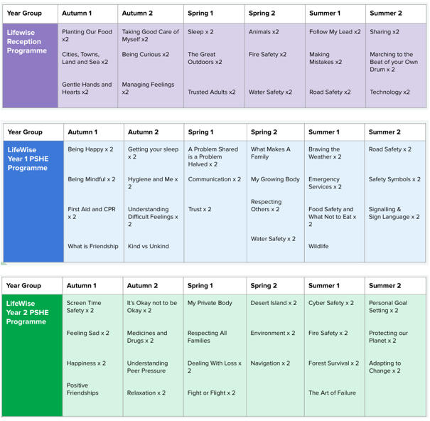
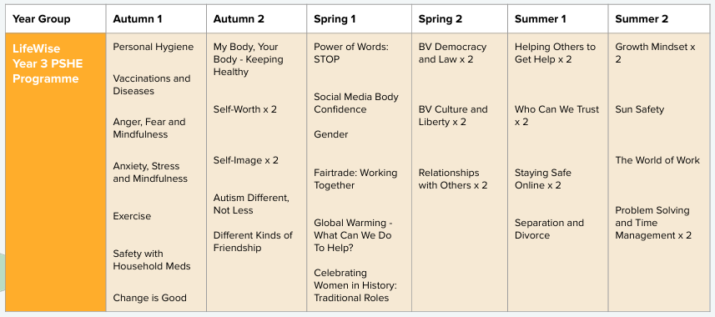
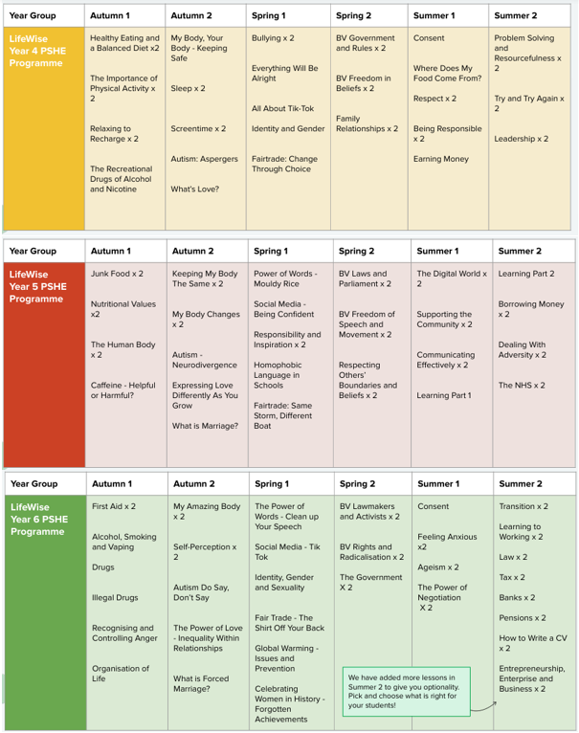

PARENT FORM -
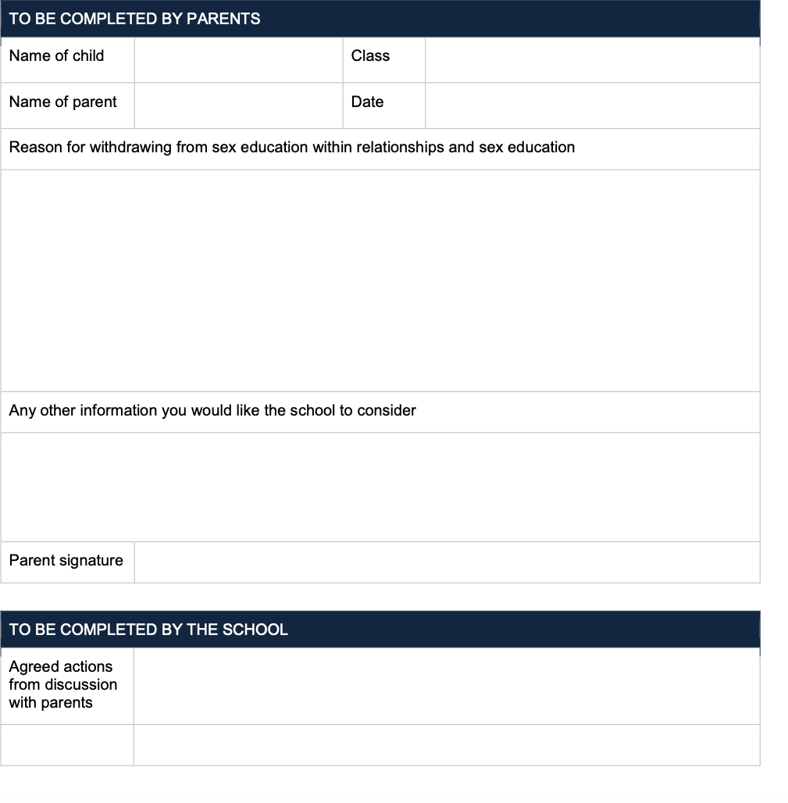
WITHDRAWAL FROM SEX EDUCATION WITHIN RSE

