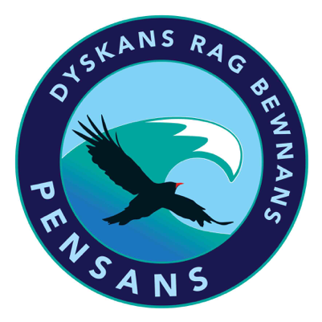
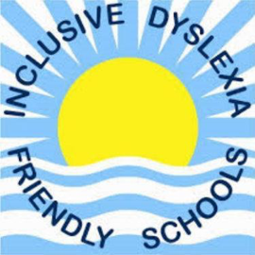
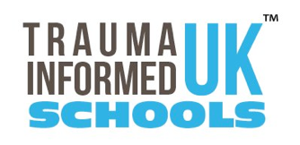
Pensans Community Primary School
Madron Road, Penzance, Cornwall TR20 8UH
Headteacher: Mrs N Ambrose B.Ed (Hons) NPQH
pensans@tpacademytrust.org
www.pensansprimary.co.uk
01736 363627

25.6.26
Dear Parents and Carers,
As part of our commitment to providing a broad and balanced curriculum, we support children’s personal development, wellbeing and preparedness for life through our Personal, Social, Health and Economic (PSHE) education programme. This includes the statutory teaching of Relationships and Sex Education (RSE), which helps children to develop the knowledge, understanding and skills needed to live safe, healthy and positive lives.
Through our RSE curriculum, children learn to:
- Understand and respect themselves and others
- Build safe, healthy and positive relationships
- Recognise inappropriate or harmful behaviour and know how to seek help
- Understand how their bodies change as they grow
- Develop confidence, resilience and a strong sense of personal safety
At Pensans, we deliver RSE through our PSHE programme using resources from Lifewise alongside materials from the Christopher Winter Project, both of which align with Department for Education statutory guidance. Lessons are taught in a safe, supportive environment using age-appropriate, factual and sensitive approaches.
Further information:
Lifewise PSHE programme: https://lifewise.co.uk/
DfE RSE guidance: https://www.gov.uk/government/publications/relationships-education-relationships-and-sex-education-rse-and-health-education
RSE parent guide: https://www.gov.uk/government/publications/relationships-sex-and-health-education-guides-for-schools
Keeping Children Safe in Education: https://www.gov.uk/government/publications/keeping-children-safe-in-education--2
Christopher Winter Project: https://www.teachsre.co.uk/christopher-winter-project-cwp-resources/2026/1/30/the-christopher-winter-project-teaching-rse-with-confidence-in-primary-schools-by-teach-sre-ltd
Before the end of term, your child will take part in RSE lessons. The units covered are:
- Reception: Family & Friendship
- Year 1: My Body Belongs to Me – Growing & Caring for Ourselves
- Year 2: My Body is Growing - Differences
- Year 3: My Body, Your Body – Valuing Difference & Keeping Safe
- Year 4: Keeping My Body Safe – Growing up
- Year 5/6: My Body Changes – Puberty, Relationships & Reproduction

We understand that the subject of RSE may raise questions or concerns for some families. We want to reassure you that:
- All content is age-appropriate and delivered by trusted adults in a safe and respectful environment
- We teach using scientific, factual, and non-judgemental language
- Pupils are taught to ask questions safely and to know that their bodies and emotions are something to be respected and protected
- We teach children about what is appropriate and inappropriate behaviour, including how to report concerns
- There is a strong focus on values, care, kindness, consent, and safety
If you still have questions and want to learn more, you are warmly invited to attend an optional parent session on Thursday 2nd July at 3:30pm, where you will be able to view the materials being used and discuss how RSE is taught in school.
If you are unable to attend but would still like further information, please contact the school and we will be happy to support you.
Thank you for your continued support in working in partnership with us to ensure all children grow into safe, respectful and confident individuals.
Yours sincerely,
Mr Rutterford

