
What was The Great Fire of London and how did it change London?
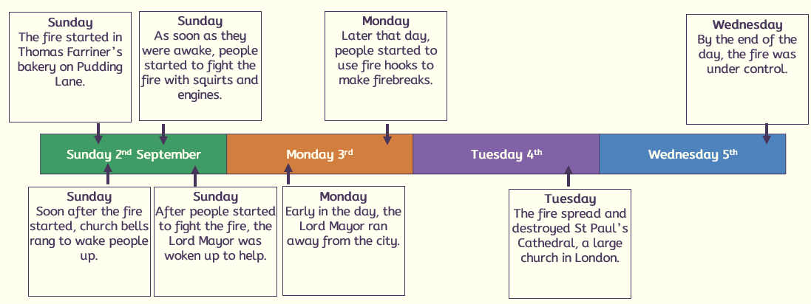
When?
 | Sessions
1 | What was London like in the 1660’s compared to today?
2 | How did the fire start?
3 | Why did the fire spread?
4 | Why did the fire burn for so long?
5 | How do we know about the Great fire of London?
6 | What changed after the Great fire of London?

- condition: the situation that something or someone one is in
- firebreak: a space between building that can stop a fire spreading
- fire hook: a long pole with a hook on the end that can pull down buildings to create firebreaks
- fire squirt: a piece of firefighting equipment used in 1660s London that was like a water pistol
- flammable: describing something that is easily set on fire
- impact: something that happens because of something else
- long-term: describing something that happens over a long time
- Lord Mayor: the person who was in charge of London, like the mayor today
- monument: something that is built to help people remember or celebrate an event
- short-term: describing something that happens quickly, over a short term
- trigger: something that causes an event to happen

Key vocabulary
- London was very
cramped and crowded.
- Houses were made of wood and were very close to each other.
- The plague in 1666 meant that people were in lockdown.
- There was lots of disease and lack of sanitation.
2
1
The fire started on Pudding lane in a bakery.
- Thomas Farriner was the baker who forgot to put his bread oven fire out.
- His house was made of wood so set a light quickly.
6
5


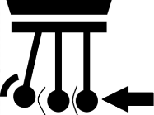
- Samuel Pepys’ diary was a primary source that told us about the fire.
- Artefacts from the time.
- Books and videos made after the event by people who were not there are secondary resources.
- London houses
were built close together and made of wood.
- It was very windy.
- No running water, so people had to run back and forth with buckets from the Thames.
- It happened at night, so people were caught unaware.
- Fire fighting
equipment was not good enough.
- Very hot summer with little rain so everything was dry.
- The Lord Mayor reacted slowly.
- Houses were all made of wood.
- There was no fire service, only volunteers.

3/4


- Houses were built further apart and were made from stone and bricks.
- The fire service was set up.
- 100,000 people were made homeless.
- St Pauls Cathedral was rebuilt and a monument of the fire.
