Rationale
Pensans School seeks to explore the aims and objectives of the National Curriculum to form a basis of planning the Geography Curriculum.
In Pensans, we follow a question-based approach to geography. This is largely led by United Curriculum and adapted by us to form a curriculum that has relevant and coherent substantive knowledge of the world which is built gradually using subject-specific pedagogy from EYFS to Year 6 and beyond.
Substantive knowledge (and our vertical concepts) - this is the conceptual/procedural knowledge and explicit vocabulary selected to build pupils’ understanding of the vertical concepts to build on the content they are learning.
Disciplinary knowledge– this considers how geographical knowledge originates and is revised. It is through disciplinary knowledge that children gradually become more expert by thinking like a geographer.
The substantive knowledge strands are under 3 main headings: Space and place, Physical processes and Human processes. These strands are weaved into a variety of topics taught in our geography curriculum allowing children to revisit concepts and build upon previously learnt knowledge. Details of the substantive knowledge being taught can be found on each topic’s knowledge organisers. This also covers our procedural knowledge which refers to the skills of being a geographer: such as types of maps or constructing and reading graphs.
The disciplinary strands of geography that we look at are: enquiry and fieldwork, comparisons, interconnections and forming judgments. These are threaded throughout our geography curriculum and are linked to our enquiry questions ensuring all children access these. Fieldwork is an incredibly big part of ‘thinking like a geographer’, therefore features heavily in our curriculum. It allows us to take our theoretical knowledge out into the real world, seeing processes come alive. At Pensans, fieldwork opportunities and skills make the most of our school grounds, school locality and wider locality. Details of how these progress can be found in our progression slides.

Intent
At Pensans School, our intent is to deliver a geography curriculum which is accessible to all and that will maximise the outcomes for every child so that they know more, remember more and understand more. Our curriculum for geography provides all children with relevant and coherent substantive knowledge of the world that is built gradually using subject-specific pedagogy from EYFS to Year 6 and beyond. We do this through substantive knowledge which is selected to build pupils’ understanding of three geographical vertical (main) concepts:
  - Space and Place
Developing an understanding of space through ideas related to location, distribution, pattern and distance and developing a sense of place and character through ideas related to identity, home, community, landscapes and diversity, and examining a range of case studies from across the globe.
  - Physical Processes
Understanding how the Earth’s natural processes shape and change the surface of the Earth. This includes both Geology & Earth Science aspects, such as the structure of the Earth and physical features we see on the land, as well as Environmental Science aspects, such as the weather and our changing climate. Both of these are threaded through the science curriculum too.
  - Human Processes
The processes and phenomena that are caused by or relate to people, including our use of resources; the distribution and changes to the Population & Communities; and the features of the Economy & Development.
These concepts run through the whole curriculum, with each topic having a focus eg. Here I am – linked with ‘Space and Place’. Often each topic will touch on multiple vertical concepts over the period of the sessions but will be brought back to its main concept at the end.
Through doing this, we offer a balanced view of the countries of the world, to address or even preempt misconceptions and negative stereotypes.
Alongside this, we use explicit teaching of core disciplinary knowledge, and the ability to approach challenging, geographically valid questions. Geographical enquiry skills have been sequenced across the mixed year groups and, where appropriate, we review and build on relevant knowledge that is first taught in mathematics or science, such as interpreting line graphs or setting hypotheses.
Our curriculum also offers opportunities to undertake fieldwork, outside the classroom and virtually. Fieldwork which is purposeful, and either gives pupils the opportunity to put into practice relevant disciplinary knowledge or to reinforce their substantive knowledge.
In Pensans, we do this using the United Curriculum as a base of study. This provides us with the resources and coverage needed to ensure the children have a wide range of topics as well as helping us to cover the entire National curriculum confidently. Through the fieldwork enquiries, the curriculum lends itself to children learning substantive knowledge about such areas as; climate, eco-systems or biomes etc. and then putting this knowledge to use in local fieldwork where they can learn more about our local area
Throughout the teaching of the curriculum, children will answer quizzes on specific substantive knowledge about their current topic which will inform the retrieval sessions within lessons. Alongside this, at the end of a topic, children will create their own ‘knowledge organisers’ answering the topic enquiry question – prompted by the lesson questions - using the knowledge they have learnt through each lesson in that topic.
Vocabulary and understanding vocabulary are major parts of our geography curriculum. Within each topic, children will be learning new words, what they mean and how to use them. This vocabulary will be laid out clearly on each knowledge organiser so that teachers understand the importance of children understanding these definitions. This vocabulary, twinned with other words they will have learnt in topics before, will be used on command modules during lessons.
Implementation
As a school, we maintain strong links to the National Curriculum guidelines to ensure all aspects, knowledge and skills of Geography are being taught across all year groups. We use progression grids and our own knowledge organisers to ensure there is clear skills, knowledge and vocabulary progression throughout school. Key vocabulary has been identified and included in each lessons command module.

Our lesson sequences are linked to our substantive knowledge which includes geographical skills and fieldwork, human and physical geography, place knowledge and locational knowledge. Where appropriate we use geographical sources, visitors, workshops and visits to excite and intrigue our children to find out more about the world around them.
From EYFS up to the end of KS2, the children will be taught about various geographical features, where they are in the world, the impact of humans on nature and how geography has changed over time to form the world we live in.

Structure of a lesson

Map work – Each lesson will start with a map. This could be about where a country is in the world; where continents/oceans are, differences around on the worlds, types of maps and grids, points on a map (icons) or capital cities. What do we know already and where does it relate to other geological areas?

Recap/Retrieval – Next part of the lesson should relate to what has been learnt on this topic so far – not just last lesson. How will it apply to this lesson? Look for connections between all of the lessons and the overarching enquiry question.

Expectation – Explain the learning question and what is expected by the end of this lesson, this is what you need to be able to show/tell me. How does today’s question relate/effect the over-arching enquiry question?

Teaching – Deliver through discussion and planned out questions based around knowledge, geographical sources and facts. Formative assessment will be taken place throughout the lesson through the questioning and discussions with the use of WALKTHRUs – cold calling, probing questions etc.

Output of lesson – Children will display learning in their books in a variety of ways. Some of these will be dictated by the teacher (maps, graphs, annotated drawings), and in other lessons children will be able to express their knowledge in their own way which can include writing or iPad assisted adaptations.
The individual learning in each lesson serves as a constant assessment tool to inform the teacher where to move the children onto next and what retrieval will be needed in future lessons.

Impact

What do we expect to see?
- Positive attitudes towards Geography. As children progress throughout the school, they develop a deep knowledge, understanding an appreciation of their local area and its place within a wider geographical context.
- A full coverage of the Geography National Curriculum.
- That children are provided with engaging experiences using the outdoors and local area to develop a curiosity and fascination about the world.
- Adaptions being made so that all children can access the learning.

How is Geography assessed?
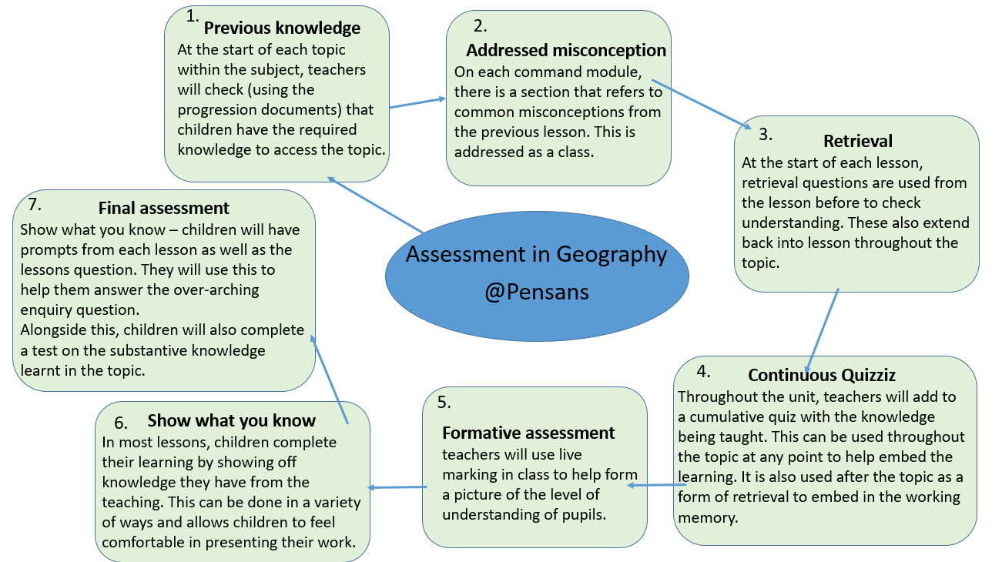
- The assessment opportunities inform teacher judgements around what a pupil has understood in each geography unit.

How do we know we have been successful?
Subject leader monitoring following the subject action plan through:
- Learning walks
- Book scrutiny
- Pupil conferencing

