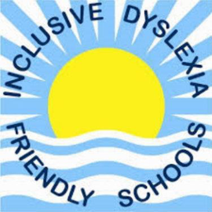


Pensans Community Primary School
Class Structure 2026-2027

HEADTEACHER
Mrs Niki Ambrose

SENDCO
Mrs Atkinson
ASSISTANT HEADTEACHER
Mr Rutterford

Y5 & Y6 Class ‘Sennen’
Mr Rutterford TA Mrs Peart

ADMINISTRATIVE STAFF
Office Manager Mrs Watling
School Administrator Mrs Scrase

Nursery/Reception Class ‘Gwithian’
Miss Catterall
TAs Mrs Mason & Mrs Bodilly
Nursery Lead – Mrs Vincent

Area Resource Base
ARB Porthmeor Class Teacher EYFS/KS1 – Mrs Browning
ARB Porthminster Class Teacher KS2 – Mrs Rollinson

SEN TAs – Mrs Cole, Mrs Farnham, Mrs Gilbert, Mrs Hoath, Mrs Reseigh & Mrs Yates

Nursery
Room Leader Miss Baldwin
TA Mrs Symons

Y1 & Y2 Class ‘Godrevy’
Mrs Earley
TA Mrs Pellow

Y3 & Y4 Class ‘Porthcurno’
Mrs Preston TA Mrs Hessell
LUNCHTIME SUPERVISORS
All TAs

PASTORAL LEAD & DSL
Mrs Miles

ADDITIONAL SUPPORT STAFF
Mrs Collins, Mrs Crummay

