**What was The Great Fire of London and how did it change London?**

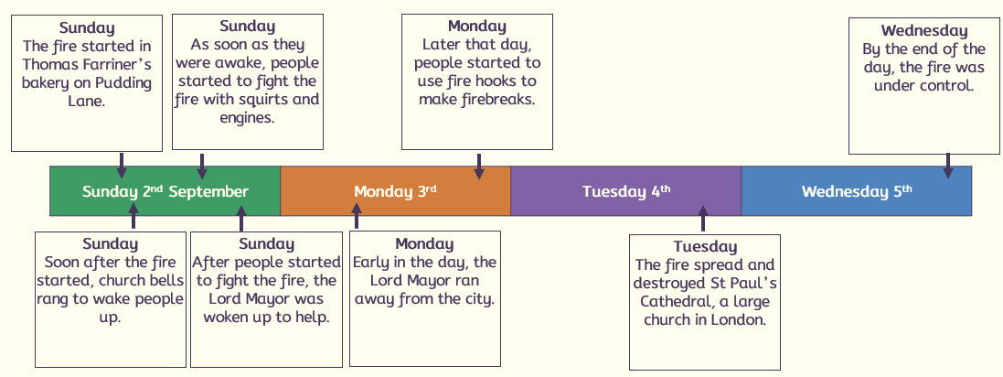

**When?**

|  |  |
| --- | --- |
|  | **Sessions** |
| **1** | **What was London like in the 1660’s compared to today?** |
| **2** | **How did the fire start?** |
| **3** | **Why did the fire spread?** |
| **4** | **Why did the fire burn for so long?** |
| **5** | **How do we know about the Great fire of London?** |
| **6** | **What changed after the Great fire of London?** |

* **condition:** the situation that something or someone one is in
* **firebreak:** a space between building that can stop a fire spreading
* **fire hook:** a long pole with a hook on the end that can pull down buildings to create firebreaks
* **fire squirt:** a piece of firefighting equipment used in 1660s London that was like a water pistol
* **flammable:** describing something that is easily set on fire
* **impact:** something that happens because of something else
* **long-term:** describing something that happens over a long time
* **Lord Mayor:** the person who was in charge of London, like the mayor today
* **monument:** something that is built to help people remember or celebrate an event
* **short-term:** describing something that happens quickly, over a short term
* **trigger:** something that causes an event to happen

**Key vocabulary**

* **London was very**

**cramped and crowded.**

* **Houses were made of wood and were very close to each other.**
* **The plague in 1666 meant that people were in lockdown.**
* **There was lots of disease and lack of sanitation.**

**2**

**1**

**The fire started on Pudding lane in a bakery.**

* **Thomas Farriner was the baker who forgot to put his bread oven fire out.**
* **His house was made of wood so set a light quickly.**

**6**

**5**



* **Samuel Pepys’ diary was a primary source that told us about the fire.**
* **Artefacts from the time.**
* **Books and videos made after the event by people who were not there are secondary resources.**
* **London houses**

**were built close together and made of wood.**

* **It was very windy.**
* **No running water, so people had to run back and forth with buckets from the Thames.**
* **It happened at night, so people were caught unaware.**
* **Fire fighting**

**equipment was not good enough.**

* **Very hot summer with little rain so everything was dry.**
* **The Lord Mayor reacted slowly.**
* **Houses were all made of wood.**
* **There was no fire service, only volunteers.**

**3/4**



* **Houses were built further apart and were made from stone and bricks.**
* **The fire service was set up.**
* **100,000 people were made homeless.**
* **St Pauls Cathedral was rebuilt and a monument of the fire.**

